name:Xianqiong Deng

Student ID: f2106

**TODO Application Report**

## Project Github link:

All source codes have been submitted the following repo:

<https://github.com/xianqiong/TodoListApp>

## Functional requirements (required/desired)

1. Display all existing tasks (required)
2. Show a detailed information about a task (required)
3. Add a new to-do task (required)
4. Update information for a task (required)
5. Delete a selected task (required)
6. Delete all tasks (desired)

## Non-functional requirements

1. The system is maintainable.
2. The UI is simple and easy to use.
3. The system is maintainable using WAMP stack.
4. Data is secure in the database.
5. The performance (including response time and throughput) needs to be good.
6. The system should be reliable.

## System Architecture Diagram

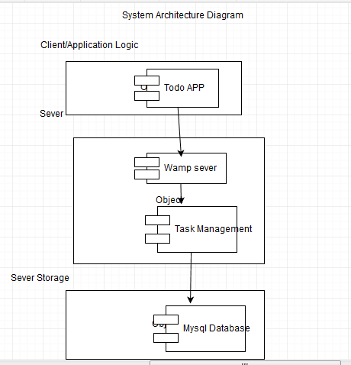

## Data Flow Diagram

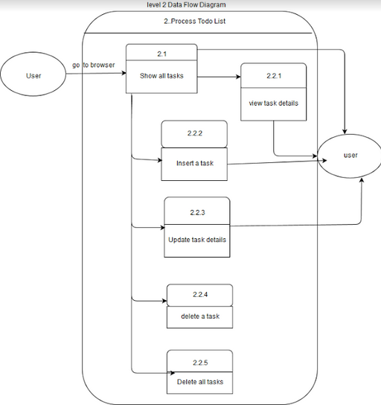

## 

## 

## Use Cases

|  |  |  |  |  |
| --- | --- | --- | --- | --- |
| Use Cases | Description | Actors | Flow | Requirement |
| 1 | View task list | User | 1. User visits the main page.  2. User clicks the task to show more details. | Show the tasks if there is at least one task to show. |
| 2 | View a task’s detail | User | 1. User clicks on the task link and navigate to the task page. |  |
| 3 | Add a task | User | 1. User inputs the task detail.  2. User clicks Add button to add task to the list. | All information must be added |
| 4 | Update a task | User | 1. Use modifies the information about the task.  2. Then clicks Save to update the task information. | User should fill out all information. |
| 5 | Delete a task | User | 1. User clicks the X button to delete a task on the main page. |  |
| 6 | Delete all tasks | User | 1. User clicks the Delete All button to delete all tasks on the main page. |  |

## Sequence Diagram

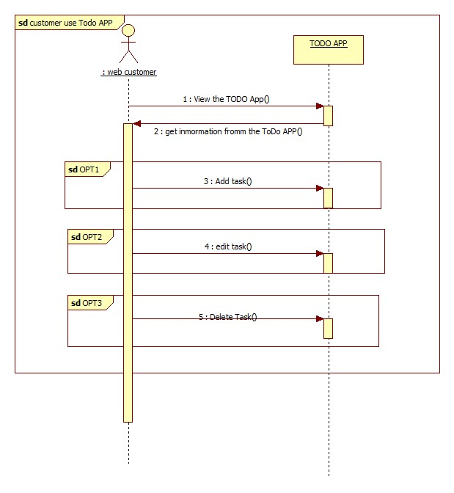

## Database Design

## 

## Class Diagram

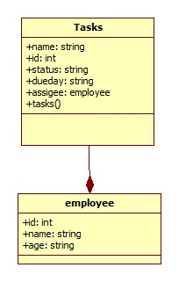

## Test Case

|  |  |  |  |  |
| --- | --- | --- | --- | --- |
| Test Case Name | Test Case Description | Step Num | Step Description | Expected Result |
| View all tasks | To verify the index.php page can list all existing tasks. | 1 | Open a browser and enter localhost/index.php. | All existing tasks would be listed on the page. |
| Add a new task | To verify that user can add a new task to the page. | 1 | In index.php page, input all information and click Add button. | New task would be added and shown on the page |
|  |  | 2 | Leave any textbox blank and click Add button. | A warning message will show up and the task will not be added to the page. |
| Display a task | To verify that use can navigate to the task detail page task.php | 1 | Click the task name on the page. | The task.php page will be shown. |
| Edit a task | To verify that task information can be edited. | 1 | In the task.php page, modify all information. Then click Save button | New information should be saved in database and shown on the page. |
|  |  | 2 | Click Return button to return to index.php page | The modified information should be shown on the page. |
| Delete a task | To verify that a task can be deleted. | 1 | Click the Delete at end of the task. | The task should be deleted and removed from the page. |
| Delete all tasks | To verify that all tasks can be deleted. | 1 | Click the Delete All Tasks button. | All tasks should be deleted and removed from the page and database as well. |

## 

## 

## Work break down:

|  |  |  |  |  |
| --- | --- | --- | --- | --- |
| Task Name | Estimated hours | Actual hours | Notes | Issues |
| Initial system design | 1 | 2 | It was my first time to do the system design. I checked online what is Todo APP and found many terminologies. According to my understanding, I drew diagrams and wrote the notes. In the Thursday class, I showed my design to TA and told him my idea to make sure I am on the right track. | In the beginning, I have no idea what exactly this assignment should be. |
| Tool installation and setup | 1 | 4 | Chosen WAMP stack based on some comparison.  Found some tutorial videos online. Learned how to install and use it. | I spend a lot of time learn how to install and use tool online . |
| Front End development | 5 | 8 | I know basic information about HTML, but I only know how to create simple pages. | Implementing the ideals is not as easy as I thought. I forgot many skills I learned before. |
| Back End development | 5 | 10 | I learned how to connect database using PHP. It is all new to me. | How to connect to back end , database is problem to me. This is new to me. progress very slowly. |
| Testing | 0.5 | 1 | I tested all workflow. I found some bugs and fixed them. | Still some improvement could be done. |
| Documentation | 2 | 6 | There are many diagrams that I haven’t even heard. I found right tools and learned to draw the diagrams using a lot of time . Drawing a diagram is not difficult. | so many terminologies are new for me. I spend a lot time to find what this and how to do it. |